## MODULE CLIENT SIDE

### CONTENTS

**This module has the following files:**

1. MODULE_CLIENT_SIDE.doc
2. MODULE_CLIENT_SIDE_MEDIA.zip

### INTRODUCTION

In recent years internet has become our basic daily source and needs, enabling the dissemination of information in an inexhaustible content and interaction. Games uses has gained a promined role in nowadays computer usage, allowing people to get access to entertainment from any places.

You are asked to develop game called **Flipping** using HTML and CSS and develop client-side programming using JavaScript and its open source libraries. Some media files are available to you in a zip file. You can create more media and modify anything in the media if you want.

Your game needs to be developed in a tablet resolution (960x600 pixels). In bigger resolution, the game must be centred in the screen both horizontally and vertically.

### DESCRIPTION OF PROJECT AND TASKS

This is a module of 5 hours. Your first 2.5 hours must be used to create the design of the game in three PNG images and the initial layout using HTML/CSS. Your layout should follow the design that you created. The final 2.5 hours you will create the functionality of game using JavaScript that allows the game to work correctly in different web browsers.

Flipping game board are described below:

1. Board consist of **8x8 board** and 64 discs, 32 black and 32 white.
2. **Place 2 black and 2 white discs at the centre of the board**. Arrange the discs with matching colour diagonal to each other.
3. Total discs form each colour.

**FIRST 2.5 HOURS – DESIGN AND INITIAL LAYOUT:**

1. **Deliver at least 3 PNG image files that present:**
   1. Game Instructions: The first screen of the game presents the instructions to the player, a text field for player’s name, and the “Colour” buttons for choosing color. The instructions for the game are included in the media files. The “Colour” button should be disabled if the text field is empty.
   2. Game board layout: It must present all elements described above in the game screen.
   3. Game Icon which represent the game immediately.
2. **Develop the initial markup (HTML + CSS) of your game application.** When the layout is accessed the game is presented to the user with the game instructions and the button “Start Game”. The instructions must be presented in an animated way.
3. **“Colour” buttons must have active and hover effects.** The background of the buttons in hover state must be: #e2e9fc for white and #272729 for black. The active state must use #0069d9.
4. **The HTML and CSS** code must be valid in the W3C standards for HTML5 and CSS3 rules.

**FINAL 2.5 HOURS – GAME FUNCTIONALITIES:**

1. **Black always goes first in Flipping**. Player can choose between white or black; opposite colour will be run by computer.
2. **Pressing the “Colour” button in the initial screen will begin** the countdown from 3 before the game starts. Player cannot do anything in this state. After the countdown reaches 0, player can start playing the game with the 8x8 board.
3. **Game will shows every possible legal move suggestion** so it would be easier for players to make decisions. The suggested board should be highlighted.
4. **Player can click any suggested legal moves** to choose it. The chosen spot should be animated to show the board are chosen. If Player click on board without suggestion moves, animate and highlight all possible legal move.
5. Disc with colour based on player’s colour will **appear** on spot player had chosen in advance.
6. **Place disc in a spot that surrounds an opponent’s disc**. This is also known as “outflanking”. A “row” consists of one or more discs that form a line horizontally, vertically, or diagonally.
   1. For example, if the opponent has a disc next to 1 of your discs in a vertical row, then place a disc on the open side of their disc in the same row to outflank your opponent’s disc
7. **Flip the outflanked disc to its opposite side.** Once a disc is outflanked, flip it over to the opposite colour. However, the same disc may be turned over again if it is part of a row that is outflanked.
8. **Create** **score** **counters** which will count every disc on each colour in order to determine who will win at the end of the game.
9. **Pass the turn to your opponent to continue playing.** Each Player goal is to place a disc in a spot that outflanks at least 1 of the other player’s discs.
10. **Continue taking turns placing discs until a legal move isn’t possible.** Always place discs in a position where they can outflank a row of the opponent’s discs. If this isn't possible, you must forfeit your turn until you can perform a legal move. If neither player can perform a legal move, then the game is over.
11. **Save the player current score as high score in the local storage** when the game is over (whether the black or white won) if it is higher than the current score.
12. **Use your talent to increase the usability of the game** as much as possible to permit a better experience for the user.
13. **There must be an option to disable/enable game sounds.** If the sound is disabled, none of sounds should be played. If sound is enabled all sounds must be played.
14. **Your game should work without JavaScript errors** or messages shown in the browser console.
15. **Maintain your HTML/CSS and JavaScript code organized and clean to facilitate future maintenance.** Use correct indentation and comments. Use meaningful variable names and document your code as much as possible so another developer would be able to modify your work in the future
16. The game needs to work correctly in **Google Chrome**

### INSTRUCTIONS TO THE COMPETITOR

1. The media files are available in the ZIP file. You can modify the supplied files and create new media files to ensure the correct functionality and improve the application.
2. Save your design files in a folder call "**XX_CLIENT_SIDE_MODULE/design**" where XX is your computer number.
3. You should create additional images for each of the requested resolution to highlight hidden elements, animations, interactions, or any additional information that will assist in the presentation of the game design.
4. Additional file names
   1. Instructions: XX_instructions_2.png, XX_instructions_3.png
   2. Game board: XX_game_board_2.png, XX_game_board_3.png
5. Save any image source files to a folder named "**source**" inside the "**XX_CLIENT_SIDE_MODULE/design**" folder. The source files are the files that contain the layers, development files, ie .psd, .ai, .svg, .jpg.
6. Save the working game to the directory on the server named "**XX_CLIENT_SIDE_MODULE**". Be sure that your main file is called index.html.
7. You are responsible for the time management in your development. If you finalize some tasks you can continue to other tasks. The initial 2.5 hours only define what will be evaluated first.

**EXAMPLE**

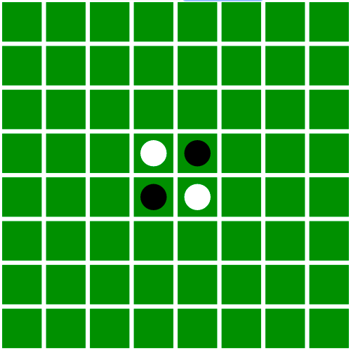

**Image 1** Shows initial position Flipping Game

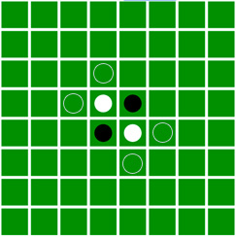

**Image 2** Legal Move Suggestion

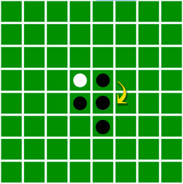

**Image 3** Black Outflank White